**Grove - Temp&Humi Sensor**

窗体顶端

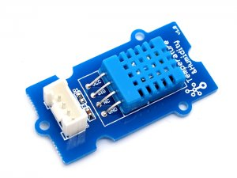

http://www.seeedstudio.com/depot/includes/templates/pure_green/images/next_l.gif

* [http://www.seeedstudio.com/depot/bmz_cache/d/d1af11076fcdfbf8d9a85239a12fbdf7.image.55x41.jpg](http://www.seeedstudio.com/depot/images/P2100715.jpg)
* [http://www.seeedstudio.com/depot/bmz_cache/7/7aaf264e887368045aeb2988f4761ce6.image.55x41.jpg](http://www.seeedstudio.com/depot/images/P2100715_01.jpg)

http://www.seeedstudio.com/depot/includes/templates/pure_green/images/next_r.gif

* **Price:**

$5.90  [(Price Feedback)](javascript:void())

* **SKU:**

SEN11301P

* **Units in Stock**

53

* **Designed by:**

[Seeed Studio](http://www.seeedstudio.com/)



[Other products from designer](http://www.seeedstudio.com/depot/seeed-studio-m-23.html)

* **Quantity:** Max: 53  
  
* [Add to Wish List](http://www.seeedstudio.com/depot/index.php?main_page=un_wishlist&products_id=745&cPath=144_147&action=un_add_wishlist)

Description

This temperature & humidity sensor provides a pre-calibrated digital output. A unique capacitive sensor element measures relative humidity and the temperature is measured by a negative temperature coefficient (NTC) thermistor. It has excellent reliability and long term stability. Please note that this sensor will not work for temperatures below 0 degree.

**Features**

* Relative Humidity and temperature measurement
* Full range temperature compensation Calibrated
* Digital signal Long term stability
* Long transmission distance
* Low power consumption

**Documents**

Please visit our[wiki](http://www.seeedstudio.com/wiki/Grove-_Temperature_and_Humidity_Sensor)page for more info about this product. It will be appreciated if you can help us improve the documents, add more demo code or tutorials. For technical support, please post your questions to our [forum](http://www.seeedstudio.com/forum/).

窗体底端

s